FORNAX™ ePlanCheck Rule
Rule Information
Rule ID | SSW 3.3.3.4 (a)
Rule Name | Flush Valve Usage
Chapter | Part 3 Sanitary Works
Section | 3.3.3 Acceptable Practices on Installation of Sanitary Appliances
Handbook | Code of Practice on Sewerage and Sanitary Works (1st Edition - Mar 2000) (Updated: Nov 2004)

Rule Description
3.3.3.4 Flush Valve (3-26)

(a) The flush valve shall conform to the requirements in the SS CP 48 - Code of Practice for Water Services.

[Note : Under the Public Utilities (Water Supply) Regulations, (1) a flush valve for a water closet shall deliver not more than 4.5 litres of water per flush and a flush valve for urinal shall deliver not less than 1.5 litres and not more than 2.5 litres of water for individual urinal unit; (2) Flush valve shall not be used in residential premises.]

Rule Interpretation
- This rule stipulates two items to which one is a performance clause and the other, is to check for the usage of flush valves on residential premises.
- A flush valve is a self-closing valve designed to release a large volume of water when activated. This mechanism is often used to flush a toilet or urinal. The valve and associated hardware are located within the toilet tank or in the body of the urinal.
- The usage of flush valves in residential premises is not allowed, however, on areas where usages of such valves are allowed, it should conform to the requirements in the SS CP 48 - Code of Practice for Water Services.

Rule Scenario

Scenario 01 – Compliant
Requirement | Flush valve shall not be used on residential areas.
Description | Water closet cistern or tank type is used in a residential bathroom.
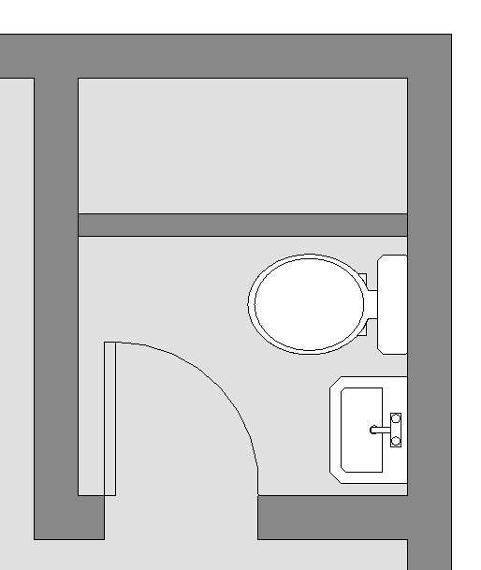

Water Closet Cistern or Tank Type

PLAN

FIGURE SCENARIO

Scenario 01 – Non Compliant
Requirement | Flush valve shall not be used on residential areas.
Description | Water closet flush valve type is used in a residential bathroom.
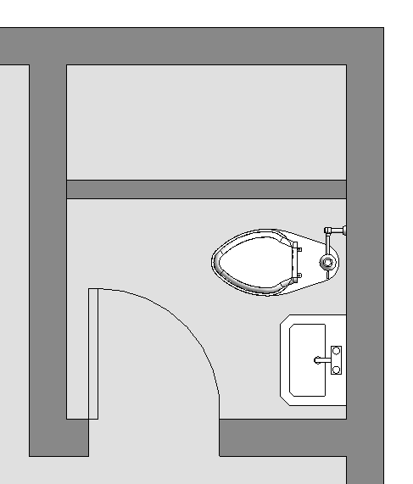

Water Closet Flush Valve Type

PLAN

FIGURE SCENARIO

Request For Information
- What defines a residential area?
- What other types of water closet are applicable for residential areas?

Model PreCheck

Required Elements | Required Attributes
IfcSite | Project Development Type contains “Residential”
FlowTerminal | IfcName contains “WC Flush Type”
FlowTerminal | IfcName contains “UR Flush Type”

Rule Parameters

System Type
Cold Water
Hot Water
 | Sanitary | 
 | Sewerage
Vent

Space Type 1
State | Type | Property | Operator | Value
Include | IfcSite | Project Development Type | Contains | Residential
Exclude |  | Any | Match | N.A.
 |  |  | N.A. | <User defined>

Element Type 1
State | Type | Property | Operator | Value
Include | FlowTerminal | IfcName | Contains | WC Flush Type
Include | FlowTerminal | IfcName | Contains | UR Flush Type
Exclude |  | Any | Match | N.A.
 |  |  | N.A. | <User defined>

Space Type 1 Condition

* Shall not be provided with Element Type 1.

Result Messages
- 3.3.3.4 (a) Flush Valve Usage
  - Compliant (TotalResultNumeric)
    - BuildingStorey (TotalResultPerFloorNumeric)
      - ProjectDevelopmentType: WC Cistern Type is provided.
  - Non-Compliant (TotalResultNumeric)
    - BuildingStorey (TotalResultPerFloorNumeric)
      - ProjectDevelopmentType: WC Flush Type is provided.
  - Attention (TotalResultNumeric)
    - BuildingStorey (TotalResultPerFloorNumeric)
      - ProjectDevelopmentType: No WC found.

Sample Result Messages
- 3.3.3.4 (a) Flush Valve Usage
  - Compliant (1)
    - Level 1 (1)
      - Residential: WC Cistern Type is provided.
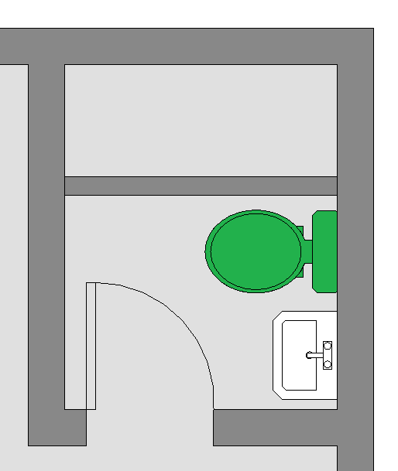

PLAN

  - Non-Compliant (1)
    - Level 1 (1)
      - Residential: WC Flush Type is provided.
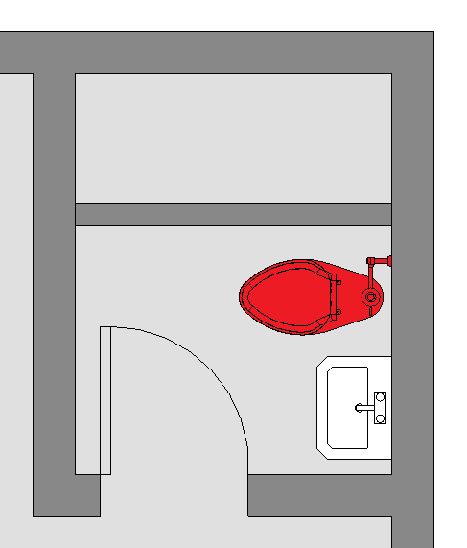

PLAN

  - Attention (1)
    - Level 1 (1)
      - Residential: No WC found.

Sample Result Model Views
- 3.3.3.4 (a) Flush Valve Usage
- Compliant
- Plan view.
    - Highlight checked element/space.
    - All other elements are in translucent except checked element/space.
- Non-Compliant
- Plan view.
- Highlight checked element/space.
- All other elements are in translucent except checked element/space.
- Attention
- Plan view.
- Highlight checked element/space.
- All other elements are in translucent except checked element/space.

Testing Scenario Notes
- Scenario 01 – Compliant
- Ground Floor Level
- A residential house has a Water Closet Cistern Type in the bathroom.

- Scenario 01 – Non Compliant
- Ground Floor Level
- A residential house has a Water Closet Flush Valve Type in the bathroom.

- Attention 01
- No water closet found.

Model:
SSW 3.3.3.4 a - 001 Scenario 01 Compliant.ifc
SSW 3.3.3.4 a - 001 Scenario 01 Non-Compliant.ifc

Modelling Guideline
- Specify IfcSite containing “Residential” for relevant ProjectDevelopmentType.
- Specify IfcName containing “WC Flush Type” for relevant FlowTerminal.
- Specify IfcName containing “UR Flush Type” for relevant FlowTerminal.

Specification Log
RA | Reymart Sisgon
Last edit date | 09 November 2018
ePC version
Updates | - V1

